Automation with Crontab Theory (1 hour):Scheduling tasks using crontab.Use cases for automation in Linux.Practical (1 hour):Automate backups of critical directories.Task: Submit a backup configuration and log output.
Tasks
1.List 3 real-life scenarios where automating tasks with crontab would be useful on a Linux server, and write one line explaining the benefit for each.
1. Three Real-Life Scenarios of Crontab
1. Automatic Backup
A Linux server can use crontab to automatically back up important files or databases every day.
Benefit: It reduces manual work and helps protect data from accidental loss.
2. Log File Management
crontab can automatically archive or delete old log files at regular intervals.
Benefit: It saves disk space and prevents the server from running out of storage.
3. System Monitoring
A cron job can regularly check CPU usage, memory, disk space, or whether important services are running.
Benefit: Regular monitoring helps administrators detect server problems early.
In theory: crontab is useful because it allows Linux administrators to schedule repetitive tasks automatically at specific times or intervals, making server management more efficient and consistent.
2.Write a crontab entry that runs a script called update_playlist.sh every day at 2:00 AM to automatically update your music playlist backup, and explain what each part of the crontab line means.

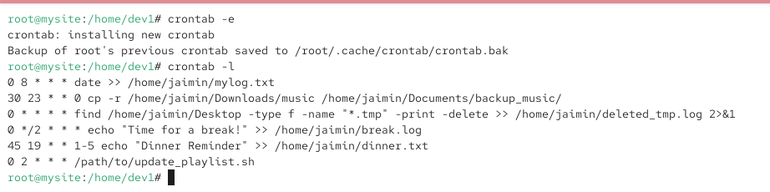
3.Create a shell script named backup_instagram_photos.sh that copies all files from /home/yourusername/InstagramPhotos to /home/yourusername/Backups/InstagramPhotos with today’s date in the backup folder name.Hint: Use the date command to generate a folder like InstagramPhotos_2024-06-10.

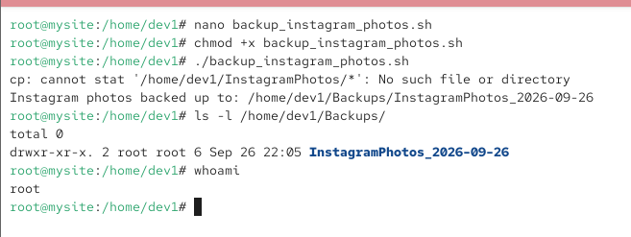
4.Schedule your backup_instagram_photos.sh script to run every Sunday at 11:30 PM using crontab, and redirect both standard output and errors to a log file named backup_log.txt in your home directory.

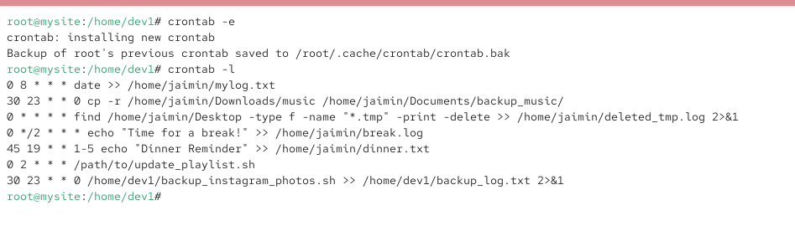
5.After your backup runs, open backup_log.txt and submit the last 5 lines as proof that your backup and logging worked.Hint: Use the tail command to view the last lines of your log.
